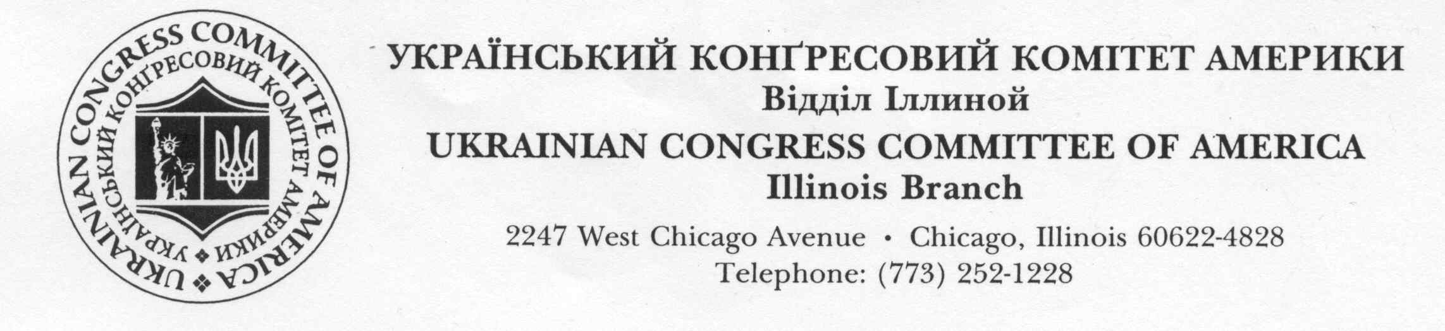
The Ukrainian Congress Committee of America (UCCA) is the oldest and largest civic organization
uniting the Ukrainian community in Chicago. On August 20 and 21, 2016 UCCA will present the 33rd
consecutive Ukrainian Days Festival held in Smith Park.

The Ukrainian Days Festival is the primary funding source for the many humanitarian and community
initiatives undertaken by UCCA throughout the year. These programs include providing assistance
to orphans, wounded soldiers, refugees and other projects in Ukraine and US.

Corporate & Business sponsorship packages are available at various opportunity levels. Platinum,
Gold, Silver and Bronze sponsors enjoy various increasing opportunities to expose their products or
services to massive numbers of attendees, which in recent years have numbered over 15,000
participants during the Festival. The enclosed sheet provides details on each sponsorship package.

To ensure maximum exposure for our sponsors we are requesting that a participation commitment
be made no later than August 1, 2016. This will ensure that your logo and advertising are included
in the various media placements.

For further information, or to firm up your sponsorship participation, contact
Ihor Diaczun (216) 870-1811
Christina Drozd (773) 314-6468

Advertising for Program Book in .jpg or .pdf format please e‐mail to: PKRUTIAK@GMAIL.COM

Sponsorship package requested: Platinum_____ Gold_____ Silver_____ Bronze_____

SIGNATURE:__________________________________ DATED: ________________________
Name / Organization / Company:
______________________________________________________________________________________
Contact Person: ________________________________________________________________________
Address: _______________________________________________________________________________
City: __________________________________________________ State: ________ Zip: ______________
Phone # ___________________________________ Fax # _____________________________________
E – Mail: ____________________________________ Web‐site: _________________________________

Make all checks payable to the UCCA.
Please return this sponsor request form with your check to:
Christina Drozd
2138 W Cortez St
Chicago IL 60622
UKRAINIAN DAYS FESTIVAL 2016
CORPORATE & BUSINESS SPONSORSHIP PACKAGES

PLATINUM $ 5,000
• Company logo to appear on stage during Festival (full screen)
• Signage* at festival entrances
• Advertising in Program book (full page)
• Company Logo to appear on promotional materials
• Free use of vendor tent (15’ x 15’) and eight tables
• Two Tickets to VIP Reception with Distinguish Guests
• Two Tickets to Concert‐Dancing Party on August 20, 9 pm at Ukrainian Cultural Center

GOLD $ 2,500
• Company logo to appear on stage during Festival (half screen)
• Advertising in Program book (full page)
• Company logo to appear on promotional material
• Four free tables inside a vendor tent
• Two Tickets to VIP Reception with Distinguish Guests
• Two Tickets to Concert‐Dancing Party on August 20, 9 pm at Ukrainian Cultural Center

SILVER $1,000
• Company Logo to appear on stage during Festival (quarter screen)
• Advertisement in Program book (half page)
• Two free tables inside a vendor tent
• Two Tickets to Concert‐Dancing Party on August 20, 9 pm at Ukrainian Cultural Center

BRONZE $ 500
• Company Logo to appear on promotional material
• Advertisement in program book (half page)
• One free table inside a vendor tent
• Two Tickets to Concert‐Dancing Party on August 20, 9 pm at Ukrainian Cultural Center

*SIGNAGE
Sponsors in same sponsorship level will be required to have the same maximum size signage.
These signs are to be provided by sponsors. All signs must be delivered to the event site on
Friday by 12 noon before the event to be properly placed on the backstop.

